2/24/2023

Object Oriented Programming

Assignment-01(official)

Abdullah Shafiq

22K-4489

Question -01

#include <iostream>#include <string>class Radiator{private: int id; static int next_id; bool is_on;public: Radiator() : id(next_id), is_on(false) { next_id += 15; } int get_id() const { return id; } bool get_is_on() const { return is_on; } void set_is_on(bool value) { is_on = value; }};class Room{private: std::string name; int max_people; int num_radiators; int radiator_ids[2];public: Room(const std::string &name) : name(name), max_people(12), num_radiators(0) {} const std::string &get_name() const { return name; } bool add_radiator(const Radiator &radiator) { if (num_radiators >= 2) { return false; } for (int i = 0; i < num_radiators; ++i) { if (radiator_ids[i] == radiator.get_id()) { return false; } } radiator_ids[num_radiators++] = radiator.get_id(); return true; } int get_num_radiators() const { return num_radiators; } const int *get_radiator_ids() const { return radiator_ids; }};int Radiator::next_id = 0;int main(){ std::cout << "Name: Hafiz Muhammad Abdullah.\n"; std::cout << "Roll ID: 22K-4489\n"; std::string student_id; std::cout << "Enter student ID: "; std::cin >> student_id; Radiator radiator1, radiator2, radiator3; Room room("Classroom"); if (room.add_radiator(radiator1)) { std::cout << "Radiator 1 added to " << room.get_name() << std::endl; } else { std::cout << "Failed to add radiator 1 to " << room.get_name() << std::endl; } if (room.add_radiator(radiator2)) { std::cout << "Radiator 2 added to " << room.get_name() << std::endl; } else { std::cout << "Failed to add radiator 2 to " << room.get_name() << std::endl; } if (room.add_radiator(radiator3)) { std::cout << "Radiator 3 added to " << room.get_name() << std::endl; } else { std::cout << "Failed to add radiator 3 to " << room.get_name() << std::endl; } std::cout << "Number of radiators in " << room.get_name() << ": " << room.get_num_radiators() << std::endl; const int *radiator_ids = room.get_radiator_ids(); for (int i = 0; i < room.get_num_radiators(); ++i) { std::cout << "Radiator " << i + 1 << " ID: " << radiator_ids[i] << std::endl; } return 0;}

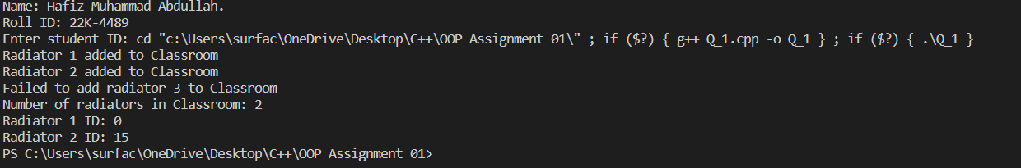

Question -02

#include <iostream>#include <cstring>#include <sstream>using namespace std;class Admin;class Data_scientist{private: int unique_id; string first_name; string last_name; string highest_education; int age; string country; int num_ans_given; int num_ans_asked; int users;public: Data_scientist(int unique_id, string first_name, string last_name, int age, string country) { this->unique_id = unique_id; this->first_name = first_name; this->last_name = last_name; this->highest_education = "MS-CS"; this->age = age; this->country = country; } void set_num_ans_asked(int num_ans_asked) { this->num_ans_asked; } void set_num_ans_given(int num_ans_given) { this->num_ans_given; } void set_user_count(int users) { this->users = users; } int get_user_count() { return users++; } string get_first_name() { return first_name; } string get_last_name() { return last_name; } int get_age() { return age; } string get_country() { return country; } string fixed_edu() { return highest_education; } int get_ans_given(int num_ans_given) { return num_ans_given++; } int get_ans_asked(int num_ans_asked) { return num_ans_asked++; }};class Admin{ string first_name; string last_name; int age; string country; int admin_id; int users;public: Admin(int admin_id) { if (admin_id == 4489) { this->admin_id = admin_id; this->first_name = "Admin 22k-4489\n"; this->last_name = "Abdullah Shafiq"; cout << first_name; cout << last_name; } else { cout << "You are not an Admin."; } } void set_users(int users) { this->users = users; } int get_users() { return users; }};int main(){ cout << "Name: Hafiz Muhammad Abdullah." << endl; cout << "Roll ID: 22K-4489" << endl; string id; string extracted_digits; int extracted_digits_int; int option; int opt; int admin_id; string f_name; string l_name; int age; string country; int users = 0; cout << "Enter Your ID: "; cin >> id; extracted_digits = id.substr(id.length() - 3, 2); stringstream ss; ss << extracted_digits; ss >> extracted_digits_int; do { cout << "Enter The Options\n"; cout << "1-Create User\n"; cout << "2-Log in as Admin\n"; cin >> option; switch (option) { case 1: { users++; cout << "Enter First Name:";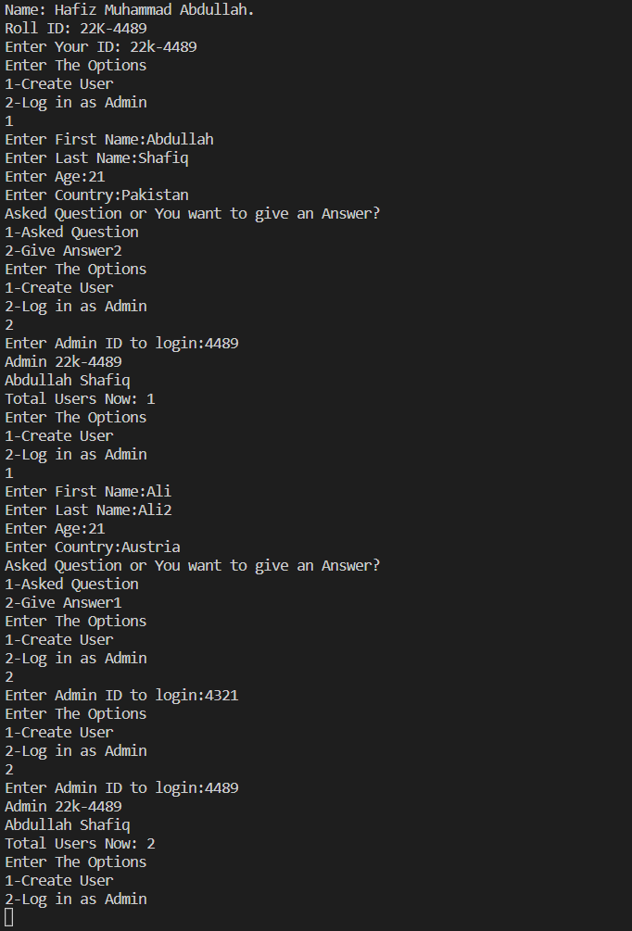 cin >> f_name; cout << "Enter Last Name:"; cin >> l_name; cout << "Enter Age:"; cin >> age; cout << "Enter Country:"; cin >> country; Data_scientist data(extracted_digits_int, f_name, l_name, age, country); cout << "Asked Question or You want to give an Answer?"; cout << "\n1-Asked Question\n2-Give Answer"; cin >> opt; if (opt == 1) { data.set_num_ans_asked(1); } else if (opt == 2) { data.set_num_ans_given(1); } } break; case 2: { cout << "Enter Admin ID to login:"; cin >> admin_id; if (admin_id == 4489) { Admin admin(admin_id); admin.set_users(users); cout << "\nTotal Users Now: " << admin.get_users() << endl; ; } } break; case 3: { exit(0); } } } while (opt != 3);}

Question -03

#include <iostream>#include <cstring>#include <sstream>using namespace std;class HeartRates{ string name; int unique_id; int day; int month; int year; int age;public: void set_name(string name) { this->name = name; } string get_name() { return name; } void set_unique_id(int id) { this->unique_id = unique_id; } int get_unique_id() { return unique_id; } void set_birthday(int day, int month, int year) { this->day = day; this->month = month; this->year = year; } int get_birthday() { this->age = 2023 - year; return age; } int get_rate() { return (220 - age); } string target_hr() { int upper, lower; upper = 0.85 * get_rate(); lower = 0.50 * get_rate(); return (to_string(upper) + "-" + to_string(lower)); } HeartRates(string name, int unique_id, int day, int month, int year) { set_name(name); set_unique_id(unique_id); set_birthday(day, month, year); }};int main(){ cout << "Name: Hafiz Muhammad Abdullah." << endl; cout << "Roll ID: 22K-4489" << endl; string name; int day, month, year; string id; string extracted_digits;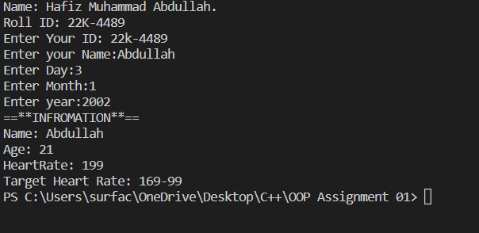 int extracted_digits_int; cout << "Enter Your ID: "; cin >> id; extracted_digits = id[6]; stringstream ss; ss << extracted_digits; ss >> extracted_digits_int; cout << "Enter your Name:"; cin >> name; cout << "Enter Day:"; cin >> day; cout << "Enter Month:"; cin >> month; cout << "Enter year:"; cin >> year; HeartRates HR(name, extracted_digits_int, day, month, year); cout << "==**INFROMATION**==" << endl; cout << "Name: " << HR.get_name() << endl; cout << "Age: " << HR.get_birthday() << endl; cout << "HeartRate: " << HR.get_rate() << endl; cout << "Target Heart Rate: " << HR.target_hr() << endl;}

Question -04

#include <iostream>#include <cstring>#include <sstream>using namespace std;class Movie{ string movie_name; string show_time;public: Movie() { this->movie_name = "The Legend"; this->show_time = "10:00 PM to 1:00 AM"; } string get_mov_name() { return movie_name; } string get_show_time() { return show_time; }};class ticket{ int row_number; int seat_number; int ticket_id; bool status;public: void set_row(int row_number) { this->row_number = row_number; } void set_seat(int seat_number) { this->seat_number = seat_number; } void set_id(int ticket_id) { this->ticket_id = ticket_id; } int get_row() { return row_number; } int get_seat() { return seat_number; } int get_id() { return ticket_id++; }};int main(){ cout << "Name: Hafiz Muhammad Abdullah." << endl; cout << "Roll ID: 22K-4489" << endl; string id; string extracted_digits; int extracted_digits_int; cout << "Enter Your ID: "; cin >> id; extracted_digits = id.substr(4, 2); stringstream ss; ss << extracted_digits; ss >> extracted_digits_int; cout << extracted_digits_int; int option; int r_number;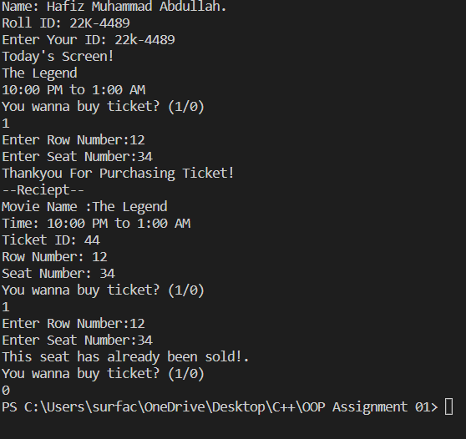 int s_number[50]; int inc = 0; Movie m; ticket t; cout << "Today's Screen!\n"; cout << m.get_mov_name() << endl; cout << m.get_show_time() << endl; t.set_id(extracted_digits_int); do { cout << "You wanna buy ticket? (1/0)\n"; cin >> option; if (option == 1) { inc++; cout << "Enter Row Number:"; cin >> r_number; cout << "Enter Seat Number:"; cin >> s_number[inc]; t.set_row(r_number); t.set_seat(s_number[inc]); for (int i = 0; i < inc; i++) { if (s_number[inc] == s_number[i]) { cout << "This seat has already been sold!.\n"; } else { cout << "Thankyou For Purchasing Ticket!\n"; cout << "--Reciept--\n"; cout << "Movie Name :" << m.get_mov_name() << endl; cout << "Time: " << m.get_show_time() << endl; cout << "Ticket ID: " << t.get_id() << endl; cout << "Row Number: " << t.get_row() << endl; cout << "Seat Number: " << t.get_seat() << endl; } } } } while (option != 0);}

Question -05

#include <iostream>#include <string>using namespace std;class User{ string fname; string lname; string id[2]; int age; int height; int shoe_size; char gender; string demographic;public: User() {} User(string fname, string lname, int age, int height, int shoe_size, char gender) { this->fname = fname; this->lname = lname; setId(); this->age = age; this->height = height; this->shoe_size = shoe_size; this->gender = gender; setDemographic(); } void setFirstName(string fname) { this->fname = fname; } void setLastName(string lname) { this->lname = lname; } void setId() { string ID; cout << "Enter NU id: "; cin >> ID; this->id[0] = ID.substr(0, 2); this->id[1] = ID.substr(4); } void setAge(int age) { this->age = age; } void setHeight(int height) { this->height = height; } void setShoeSize(int shoe_size) { this->shoe_size = shoe_size; } void setGender(char gender) { this->gender = gender; } void setDemographic() { if (age >= 0 && age <= 2) { demographic = "infant"; } else if (age >= 3 && age <= 9) { demographic = "toddler"; } else if (age >= 10 && age <= 12) { demographic = "child"; } else if (age > 13 && age <= 19) { demographic = "teenager"; } else if (age >= 19) { demographic = "adult"; } } string getFirstName() { return fname; } string getLastName() { return lname; } string getId() { return id[0] + id[1]; } string getDemographic() { return demographic; } int getAge() { return age; } int getHeight() { return height; } int getShoeSize() { return shoe_size; } char getGender() { return gender; }};class Shoe{ int size, width; string style, brand, colour, dem;public: void setsize(int size) { this->size = size; } void setwidth(int width) { this->width = width; } void setstyle(string style) { this->style = style; } void setbrand(string brand) { this->brand = brand; } void setcolour(string colour) { this->colour = colour; } void setdem(string dem) { this->dem = dem; } string getstyle() { return style; } string getbrand() { return brand; } string getcolour() { return colour; } string getdem() { return dem; } int getsize() { return size; } int getwidth() { return width; } Shoe(int width, string style, string brand, string colour, string dem) { setsize(size); setwidth(width); setstyle(style); setbrand(brand); setcolour(colour); setdem(dem); } Shoe() { }};int main(){ cout << "Name: Hafiz Muhammad Abdullah." << endl; cout << "Roll ID: 22K-4489" << endl; string fname; string lname; int age, height, shoe_size; char g; string dem; int size, width; string style, brand, colour; cout << "Enter first name: "; cin >> fname; cout << "Enter last name: "; cin >> lname; cout << "Enter age: "; cin >> age; cout << "Enter height: "; cin >> height; cout << "Enter shoe_size: "; cin >> shoe_size; cout << "Enter gender: "; cin >> g; User u(fname, lname, age, height, shoe_size, g); cout << "Enter shoe dem: "; cin >> dem; cout << "Enter shoe width: "; cin >> width; cout << "Enter shoe style: "; cin >> style; cout << "Enter shoe brand: "; cin >> brand; cout << "Enter shoe colour: "; cin >> colour; Shoe s(width, style, brand, colour, dem); system("cls"); int ch = 0; while (ch != 69) { cout << "1.Update user\n2.Update shoe\n3.View user\n4.View shoe\n5.End" << endl; cin >> ch; switch (ch) { case 1: cout << "1.Update first name\n2.Update last name\n3.Updateage\n4.Update height\n5.Update shoe_size\n6.Update gender\n"; cin >> ch; switch (ch) { case 1: cout << "Enter first name: "; cin >> fname; u.setFirstName(fname); break; case 2: cout << "Enter last name: "; cin >> lname; u.setLastName(lname); break; case 3: cout << "Enter age: "; cin >> age; u.setAge(age); break; case 4: cout << "Enter height: "; cin >> height; u.setHeight(height); break; case 5: cout << "Enter shoe_size: "; cin >> shoe_size; u.setShoeSize(shoe_size); ; break; case 6: cout << "Enter gender: "; cin >> g; u.setGender(g); u.getDemographic(); break; } break; case 2: cout << "1.Update shoe size\n2.Update shoe width\n3.Update shoe style\n4.Update shoe brand\n5.Update shoe colour\n6.Update shoe dem\n"; cin >> ch; switch (ch) { case 1: cout << "Enter shoe size: "; cin >> size; s.setsize(size); break; case 2: cout << "Enter shoe width: "; cin >> width; s.setwidth(width); ; break; case 3: cout << "Enter shoe style: "; cin >> style; s.setstyle(style); break; case 4: cout << "Enter shoe brand: "; cin >> brand; s.setbrand(brand); ; break; case 5: cout << "Enter shoe colour: "; cin >> colour; s.setcolour(colour); break; case 6: cout << "Enter shoe dem: "; cin >> dem; s.setdem(dem); break; } break; case 3: cout << "First name: " << u.getFirstName() << endl; cout << "Last name: " << u.getLastName() << endl; cout << "Age: " << u.getAge() << endl; cout << "Demograohic: " << u.getDemographic() << endl; cout << "Gender: " << u.getGender() << endl; cout << "ID: "; cout << u.getId(); cout << endl; cout << "Shoe size: " << u.getShoeSize() << endl; cout << "Height: " << u.getHeight() << endl; break; case 4: cout << "shoe size: " << u.getShoeSize() << endl; cout << "shoe dem: " << s.getdem() << endl; cout << "shoe width: " << s.getwidth() << endl; cout << " shoe style: " << s.getstyle() << endl; cout << "shoe brand: " << s.getbrand() << endl; cout << "shoe colour: " << s.getcolour() << endl; break; case 5: ch = 69; break; } }}